CS5560 Knowledge Discovery and Management

Problem Set (PS-2A)

June 12, 2017

Student Name: **Nikitha Kona**

ClassID: **11**

**We are supposed to build a knowledge graph for the following input (Both Schema and data graphs).**

CHICAGO (AP) — Citing high fuel prices, United Airlines said Friday it has increased fares by $6 per round trip on flights to some cities also served by lower-cost carriers. American Airlines, a unit AMR, immediately matched the move, spokesman Tim Wagner said. United, a unit of UAL, said the increase took effect Thursday night and applies to most routes where it competes against discount carriers, such as Chicago to Dallas and Atlanta and Denver to San Francisco, Los Angeles and New York.

**Schema Graph**

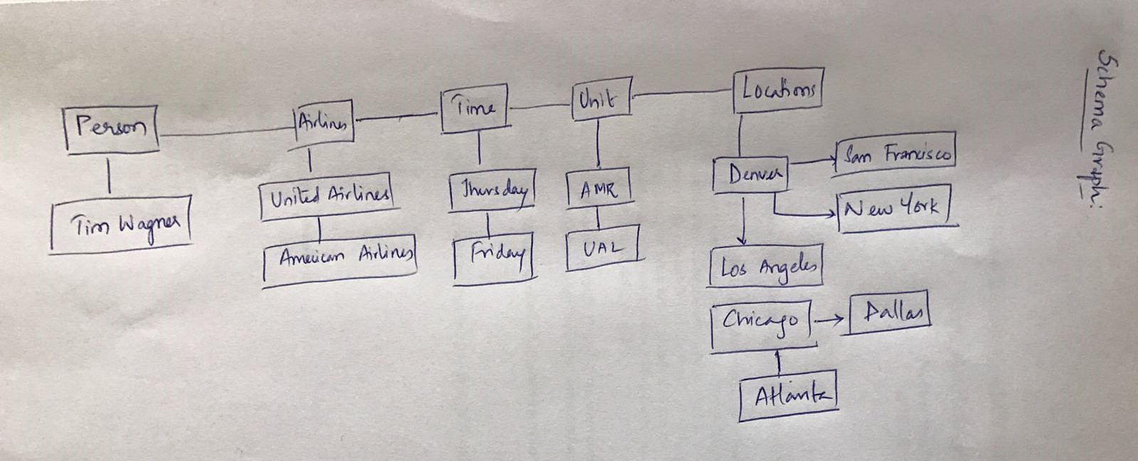

**Data Graph:**

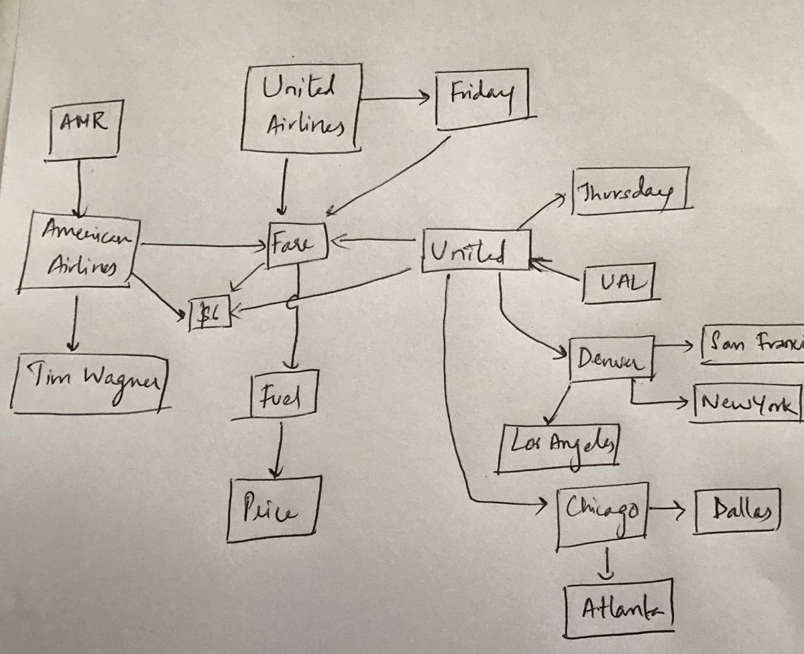

**2. Design question answering for the given input text. Try to include at least**

**one questions for the following question types.**

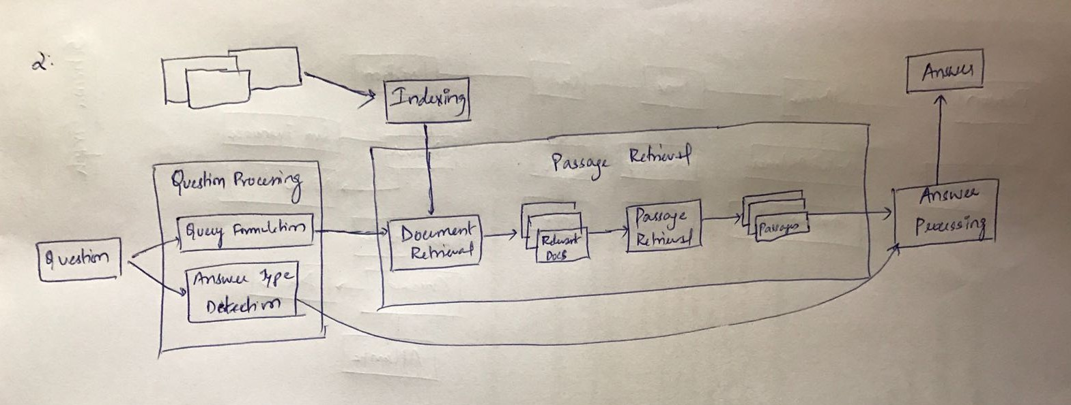

• **What** - What are the different airlines mentioned here?

• **Where** – To where is the Denver airplane flying?

• **When** – When did United Airlines said that it has increased the fares?

• **Who** – Who is the spokesman of American Airlines?

• **How** – How did United airlines countered the high fuel prices?

• **How much** – By how much did the fare for round trip in United Airlines increased?

• **Yes/No** – Did American Airlines match the move by increasing their ticket prices?